**Name (netid):** Bangyan Shi (bangyan3)

**CS 441 - HW 3: Application Domains and Foundation Models**

Complete the claimed points and sections below. Five point penalty for not filling out the points claimed section.

**Total Points Claimed [102] / 142**

1. CLIP: Contrastive Language-Image Pretraining
   1. Test CLIP zero-shot performance [10] / 10
   2. Test CLIP linear probe performance [15] / 15
   3. KNN on CLIP features [15] / 15
2. Fine-tune Model for Pets Classification
   1. Display Loaded ResNet-34 structure [5] / 5
   2. Epochs vs Loss Plots [15] / 15
   3. Best Performance [10] / 10
3. Applications of AI
   1. Describe the applications [15] / 15
   2. Positive impact [5] / 5
   3. Negative impact [10] / 10
4. Stretch Goals
   1. Compare word tokenizers [ ] / 20
   2. Implement/train custom network [ ] / 20
   3. Completed HW2 survey by Mar 9 [2] / 2

**1. CLIP: Contrastive Language-Image Pretraining**

1. CLIP zero-shot performance
   1. Your test accuracy: 67.843%
2. CLIP linear probe performance
   1. Your test accuracy: 93.627%
3. KNN on CLIP feature
   1. Your test accuracy: 85.000%
   2. Best K: 11

**2. CNN: Image Classification**

1. Network Structure and a number of parameters:

Learn_rate = 0.0001

Step_size = 5

Gamma = 0.1

1. Plot accuracy and loss:

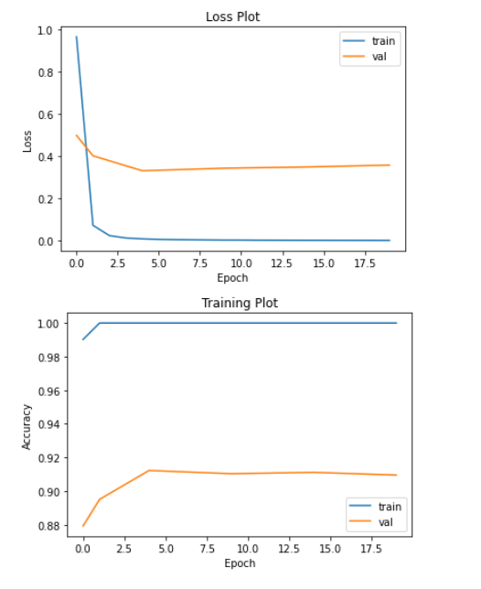

1. Your best test accuracy:

Testing accuracy: 0.9122

**3. Answer “Applications of AI” Questions**

1. How is AI used in that application area? What is the problem that AI is trying to solve, and what are the key AI/ML technologies involved? What are the technical challenges? (100+ words) [10 pts]

In the field of self-driving cars, AI and other advanced technologies are used to navigate roads and highways without the need for a human driver. (Kerem, 2022) With the help of computer vision and deep learning, they use high-resolution cameras and lidars to detect what happens in the car’s surroundings. (Edwin, 2021) In self-driving cars, we use deep learning to train artificial neural networks on large datasets and these neural networks can learn and recognize patterns in data. (Edwin, 2021) However, the most significant reason we cannot have level 5 self-driving cars is that current neural networks can replicate a rough imitation of the human vision system at best, meaning that deep learning has distinct limits. (Ben, 2020) Also, current deep learning algorithms did badly in dealing with unexpected situations on the highway which cause significant accidents. (138 words)

1. What is the actual or potential positive impact? Who is impacted? (50+ words) [5 pts]

The most significant advantage of self-driving cars is the prevention of car crashes. “Of the 37,133 vehicle fatalities in 2017, 94% of the crashes were due to human error”. (Valiente Mott) Therefore, with the help of the utilization of self-driving cars, passengers and drivers will be saved. Also, self-driving cars could reduce the cost to society, like reducing the cost of the healthcare system, transportation, and fuel. “Reports have shown that autonomous vehicles can help save society approximately 800 billion dollars each year”. (Valiente Mott) (86 words)

1. What is the actual or potential negative impact? Who is impacted? (50+ words) [5 pts]

The major disadvantage of self-driving cars is also related to the passengers. There is the possibility of hacking which will cause significant damage to daily transportation, and even lead to accidents. Because of the utilization of self-driving cars, people who depend on driving to live will lose their jobs. (Valiente Mott) All of the drivers will face losing ways to live and be forced to find new jobs. (69 words)

1. What are your sources? (include full citations and links if available) [required; half credit if not provided]

Valiente Mott. Self-Driving Cars: Pros and Cons. Retrieved from: <https://valientemott.com/auto-collisions/self-driving-cars-pros-and-cons/#:~:text=Prevention%20of%20car%20crashes&text=Computers%20based%20on%20sophisticated%20systems,accidents%20by%20up%20to%2090%25>.

Ben Dickson. Why deep learning won’t give us level 5 self-driving cars. July 29, 2020. Retrieved from: <https://bdtechtalks.com/2020/07/29/self-driving-tesla-car-deep-learning/>

Kerem Gulen. A match made in transportation heaven: AI and self-driving cars. December 29, 2022. Data conomy. Retrieved from: <https://dataconomy.com/2022/12/artificial-intelligence-and-self-driving/>

Edwin Lisowski. Artificial intelligence in self-driving cars. .addepto. July 16, 2021. Retrieved from: <https://addepto.com/blog/artificial-intelligence-in-self-driving-cars/>

**4. Stretch Goals**

1. Compare word tokenizers

Report encodings for “I am learning about word tokenizers. They are not very complicated, and they are a good way to convert natural text into tokens.” and one additional sentence of your choice. 20 points for reporting trained encodings of at least two models. 10 points for one model. You must train the models on WikiText-2 (should be included in notebook code).

BPE tokens: ['I', 'Ġam', 'Ġlearning', 'Â', 'ł', 'ab', 'out', 'Â', 'ł', 'w', 'ord', 'Â', 'ł', 't', 'ok', 'en', 'iz', 'ers', '.', 'Â', 'ł', 'T', 'he', 'y', 'Â', 'ł', 'are', 'Â', 'ł', 'n', 'ot', 'Â', 'ł', 'ver', 'y', 'Â', 'ł', 'com', 'pl', 'icated', ',', 'Â', 'ł', 'and', 'Â', 'ł', 't', 'he', 'y', 'Â', 'ł', 'are', 'Â', 'ł', 'a', 'Â', 'ł', 'g', 'ood', 'Â', 'ł', 'way', 'Â', 'ł', 'to', 'Â', 'ł', 'con', 'vert', 'Â', 'ł', 'n', 'atural', 'Â', 'ł', 'te', 'xt', 'Â', 'ł', 'int', 'o', 'Â', 'ł', 't', 'ok', 'ens', '.']

SentencePiece tokens ['▁I', '▁am', '▁learning', '▁about', '▁word', '▁to', 'ken', 'iz', 'ers', '.', '▁They', '▁are', '▁not', '▁very', '▁compl', 'icated', ',', '▁and', '▁they', '▁are', '▁a', '▁good', '▁way', '▁to', '▁con', 'vert', '▁natural', '▁text', '▁into', '▁to', 'k', 'ens', '.']

BPE tokens: ['I', 'Ġalready', 'Ġtook', 'Ġsome', 'Ġof', 'Ġthe', 'Ġc', 's', 'Ġcour', 'ses', 'Ġbut', 'Ġ44', '1', 'Ġis', 'Ġthe', 'Ġfirst', 'Ġone', 'Ġfor', 'ĠML']

SentencePiece tokens ['▁I', '▁already', '▁took', '▁some', '▁of', '▁the', '▁c', 's', '▁cour', 'ses', '▁but', '▁44', '1', '▁is', '▁the', '▁first', '▁one', '▁for', '▁ML']

1. Your implementation of Network
   1. Display the structure of the network you implemented
   2. Plot accuracy and loss
   3. Best test accuracy:

**Acknowledgments / Attribution**

List any outside sources for code or improvement ideas or “None”.